MAFI will also reduce its infusion in the six-year old 7.5 has. Tinikaran Reforestation Project as the planted trees have already hurdled rthe delicate stages and have reached the so-called self-regulating and independent age.

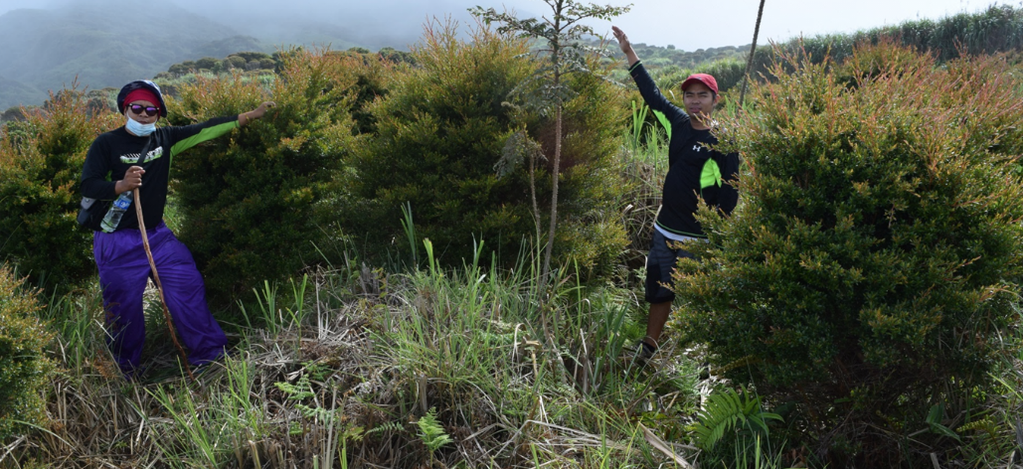

Full-grown Tinikaran plants in MAFI’s reforestation project reaching independent stage.

Ultimately, these projects will be turned over to the recipient communities and to the DENR.
Moreover, MAFI played a big role in containing the forest fire that occurred in the heart of Mount Apo Natural Park last March 2016. A group of volunteers from MAFI reforestation partners and mountain guides verged the slopes of the burning part of Mt. Apo to prevent the escalation of the fire. The volunteers stayed for three weeks at the park until such time the DENR-PAMB XII declared a total fire out.
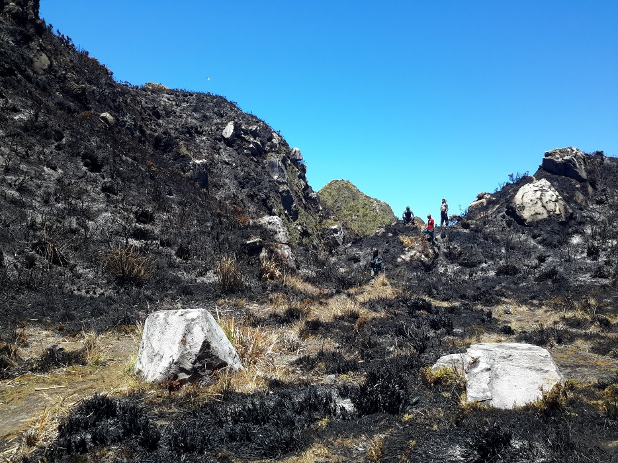
The havoc wrought by the forest fire at the peak of Mount Apo.

