COMMUNITY AND ENVIRONMENT PROGRAM (CEP)

By Edgar C. Aquiatan and Shiara S. Abarientos, RSW

***Enhancing community participation in conservation initiatives***

Our rallying cry for this program is community awareness by enhancing the creation of diversity bio-network of Mt. Apo Natural Park (MANP). This watchful value of people around and within Mt. Apo will lead them to the role of preserver and protector to head up consciousness-raised, sustainable and developed communities. We have proven this concrete notion to our project-partners after the success of our Maag and Venado Tinikaran reforestation projects in MANP. MAFI and its partners in these reforestation projects had evolved a culture of “co-ownership” in every planted Tinikaran tree. By regularly updating these partners of the development of their planted trees, we tend to inculcate values and profound awareness of the environment. This strategy proves to be a mightier hand to combat environmental problems by imploring on the bonds of conscious and environmentally-vigilant communities.

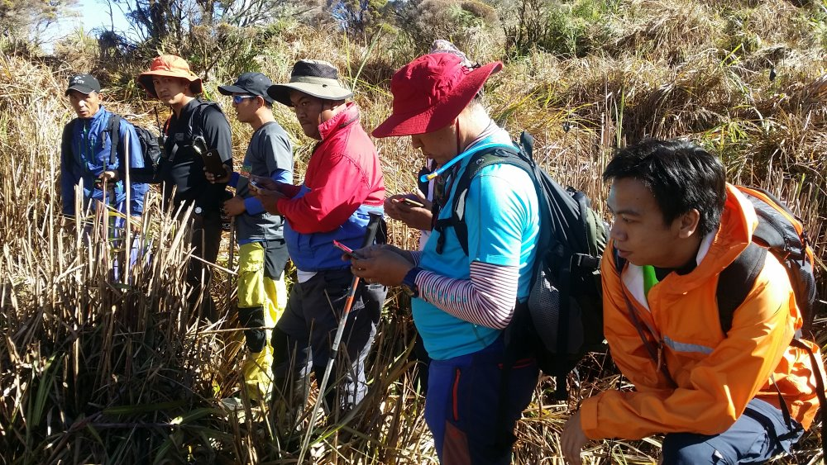

**Working for Mother Nature.** UP mountainers, EDC and MAFI staff on side trip at MAFI and EDC reforestation projects prior to their final ascent at Mt. Apo’s summit.

We continued to develop our 3.1 hectares Kiantog Agro Forestry Farm at Tagbac, Magpet to support the daily food requirements of our scholars in the MAFI dormitory and to provide immediate avenue for on-site or experimental studies of our BS Agriculture scholars. Also, we strengthened our involvement in the MANP Protected Area Management Board (PAMB) as a resource organization.

In cognizance of DSWD Standards Bureau’s mandate, MAFI went through a comprehensive barangay profiling project utilizing a Community Organizing/Community Development (CO/CD) approach in year 2016. By the end of December 2017, we completed 95% enumeration of households for the 32 barangays within MAFI’s AOR. This project will be very beneficial for the foundation as it is an effective yardstick for community capabilities to implement projects that are factually surfaced from community ideas and validated through the results of information gathered and analyzed during the conduct of the survey. Expectedly, the output of this project will be published by the end of 2018.

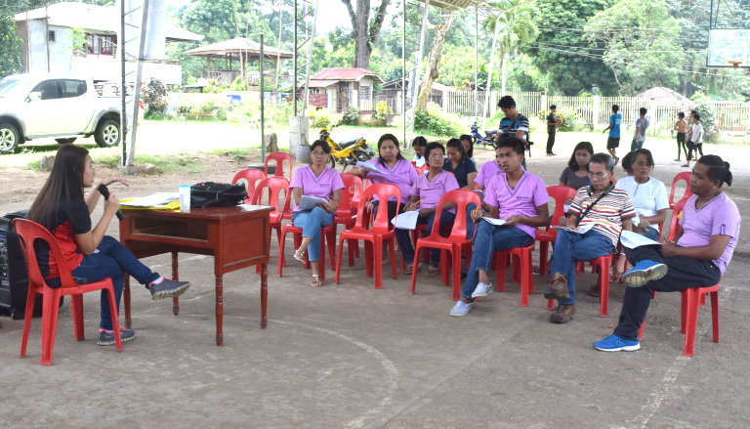

**Community orientation.** Barangay Health Workers (BHWs) attentively listened during the orientation for household survey.

