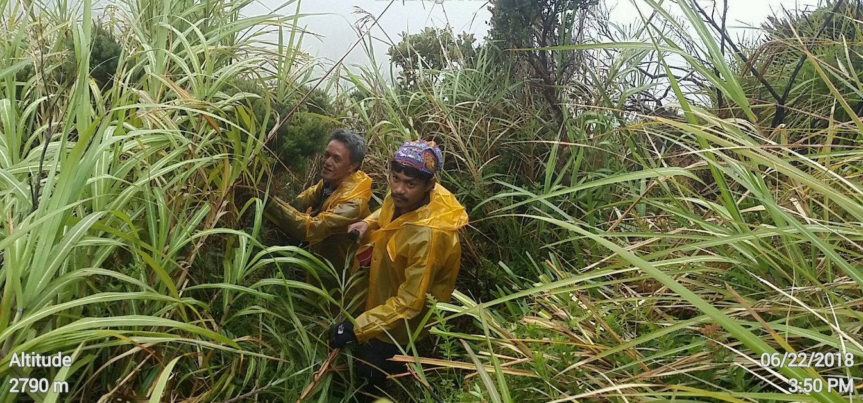

COMMUNITY AND ENVIRONMENT PROGRAM (CEP)
Strengthening partnerships and sustaining advocacies for the environment
As one of the lead resource agencies working for the protection of Mt. Apo Natural Park, MAFI continued its membership to the Protected Area Management Board (PAMB) in 2018. Notably, it sustained its networks and made leverage with other environmental groups and organizations in the AOR and in Regions XI and XII where the MANP is geographically located. An indication of which is the strong support amassed by MAFI on its request to PAMB to rehabilitate portion of the 110 hectares of forest and vegetation that were razed to the ground by a massive forest fire in March 2016. Proof of MAFI’s advancement of advocacy position was the unanimous approval by PAMB members of the Foundation’s request for rehabilitation. This initiative was lauded by PAMB stating that it was the only organization in Regions XI and XII who took the initiative of bringing back the green in the heart of forest-affected Mt. Apo Natural Park.
Consistent with PAMB’s go signal for MAFI to make the next steps through a resolution, the Foundation, in partnership with the DENR-CENRO XII and PASu Cotabato, conducted the survey mapping of the proposed 25 hectares for rehabilitation.
Other important milestones of MAFI in the latter part of 2018, achieved in partnership with DENR-PASu XII were the following:
• Participation in the “Graffiti Clean-up Drive in Mt. Apo”; the activity attempted to eradicate all forms of eye sores that desecrated the park like vandalism, stone engraving, earth mutilation and carving, among others; using pure liquefied cement, the participants wiped out thousands of names and graffiti which are engraved in the stones and boulders around the peak of Mt. Apo; and
• In partnership with GIZ Coseram, a Germany-based NGO and NCIP Regions XI and XII, MAFI sitting as NGO representative, assisted some CADT areas to harmonize some overlapping plans and validate some geographical locations and ancestral domain claims, and validate the identified stakeholders around Mt. Apo Natural Park.

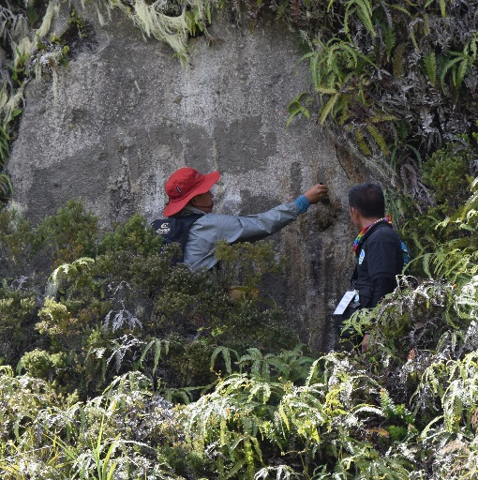
Graffiti clean-up in the boulders at the peak of Mt. Apo.

