**CULTURAL HERITAGE PROGRAMS**

**IP POPULATION WITHIN MAFI -AOR**

(Kidapawan City,Municipality of MaGpet and Makilala, Province of Cotabato)

|  |  |
| --- | --- |
|  |  |
|  |  |
|  |  |
|  |  |

|  |  |
| --- | --- |
| **MUNICIPALITY OF MAGPET** |  |
| Brgy. Bangkal | 366 |
| Brgy. Bongolanon | 160 |
| Brgy. Don Panaca | 298 |
| Brgy. Ilian | 338 |
| Brgy. Kamada | 90 |
| Brgy. Kinarum | 299 |
| Brgy. Kisandal | 101 |
| Brgy. Magkaalam | 178 |
| Brgy. Manobo | 1042 |
| Brgy. Owas | 112 |
| Brgy. Pangao-an | 194 |
| Brgy. Sallab | 362 |
| Brgy. Tagbac | 222 |
| **TOTAL** | **3,762** |

|  |  |
| --- | --- |
| **CITY OF KIDAPAWAN** | **IP RESIDENTS** |
| Brgy. Balabag | 465 |
| Brgy. Birada | 233 |
| Brgy. Ginatilan | 283 |
| Brgy. Ilomavis | 818 |
| Brgy. Indangan | 225 |
| Brgy. Luvimin | 48 |
| Brgy. Manongol | 157 |
| Brgy. Meohao | 367 |
| Brgy. Mua-an | 325 |
| Brgy. Nuangan | 287 |
| Brgy. Perez | 386 |
| Brgy. Sibawan | 124 |
| Brgy. Sudapin | 305 |
| **TOTAL** | **4,023** |

|  |  |  |  |  |
| --- | --- | --- | --- | --- |
| **MUNICIPALITY OF MAKILALA** | | |  | |
| Brgy. Buena Vida | | | 124 | |
| Brgy. Buhay | | | 204 | |
| Brgy. Garsika | | | 12 | |
| Brgy. Indangan | | | 356 | |
| Brgy. Malasila | | | 505 | |
| Brgy. Old Bulatukan | | | 455 | |
| **TOTAL** | | | **1,656** | |
|  |  | | |
|  | | | |
|  | |  | |
|  | |  | |
|  | |  | |
|  | |  | |
|  | |  | |
|  | |  | |
|  | |  | |
|  |  | | |
|  |  | | |
|  |  | | |
|  |  | | |

**CULTURAL HERITAGE PROGRAMS WORKSHOP SEMINAR**

**Workshop 1. Conducted last March 19-29, 2018, at Spotswood Methodist Center in Kidapawan City:**

**Workshop 2. Conducted last July 23-24, 2018, at Mindanao Rural Baptist Life Center, Kinuskusan, Bansalan, Davao del Sur**

**Indigenous People Institutional Development**

1. Cotabato Tribal Consultative Council for Development, Inc.(CTCCDI )

MAFI continuously provides financial assistance, technical and logistic support to the Cotabato Tribal Consultative Council for Development, Inc. CTCCDI as partners organization for the implementing its program and project and development in IP communities.

August 2017,CTCCDI BOT conduct workshop seminar in Mahomanoy Resort at Lake Agco, Ilomavis, Kidapawan City for the strengthening the organization facilitated by Ms. Nancy Ibuna from EDC.

October 24, 2017, CTCCDI participate the workshop seminar conducted by MAFI at Function Hall MAFI office , Kidapawan City .These seminar in preparation of the implementation of the Cultural Heritage Program.

Two workshop seminar of CHP on March 2018 and July 2018, 15 CTCCDI member attend and participated the seminars.

1. **Other Tribal Assistance Project ( OTAP )**

Ms. Beatriz Gosadan Faculty College and Graduates, Central Mindanao Colleges, She is the Best Presenter in Asian during the Asian Conference on Interdisciplinary Researched 2017( ACIP-2017) at Mansion Resort Hotel and Spa, Bali Indonesia last September 15-16, 2017 with the title “ Influence of Education to the Socio-Cultural and Economic Development among the Manobo in North Cotabato, Philippines” MAFI support in terms of financial assistance during his travel.



|  |  |  |  |  |  |  |  |
| --- | --- | --- | --- | --- | --- | --- | --- |
| **NO.** | **NAMES** | **SEX** | **DATE OF BIRTH** | **PLACE OF BIRTH** | **CIVIL** | **PRESENT ADDRESS** | **DESIGNATION** |
|  |  |  |  |  | **STATUS** |  |  |
| 1 | DATU.CAMILO BIDTAYAO ICDANG | M | OCTOBER 17,1954 | ICDANG VILLAGE POB.KID CITY | MARRIED | ICDANG VILLAGE POB.KID CITY | CHAIRMAN |
| 2 | DATU JEFREY ASICAM | M |  | MUA-AN,Kidapawan City | MARRIED | MUA-AN,KIDAPAWAN CITY |  |
| 3 | DATU.FERMIN ANO PINANTAO | M | JULY 4, 1935 | SUDAPIN, KIDAPAWAN CITY | WIDOWER | SUDAPIN, KIDAPAWAN CITY |  |
| 4 | DATU JONATHAN BOGAY | M |  | POB. Magpet Cotabato | MARRIED | POB.MAGPET COT. |  |
| 5 | DATU. LAMBERTO ANA DELFIN SR, | M | MAY 6, 1949 | KIDAPAWAN CITY | MARRIED | MUA-AN,KIDAPAWAN CITY |  |
| 6 | DATU. RICARDO CRISTOBAL DAMALI | M | NOVEMBER 28,1959 | KISANTE, MAKILALA, COTABATO | MARRIED | KISANDAL, MAGPET, COT. |  |
| 7 | DATU. ELMAR SIAWAN MANUMBA | M | NOVEMBER 5,1964 | TAGBAC, MAGPET, COTABATO | MARRIED | TAGBAC, MAGPET, COTABATO |  |
| 8 | DATU.ERNESTO ANDAWIT LAMBAC | M | AUGUST 27,1954 | MALASILA,MAKILALA,COT. | MARRIED | MALASILA, MAKILALA, COT. | SECRETARY |
| 9 | DATU. EDUARDO ABAD BANDA | M | FEBRUARY 10,1955 | Tungcalan, Toril, Davao City | MARRIED | POB.MAGPET COT. |  |
| 10 | DATU. NARIO MAANGUE ANDIP SR, | M | AUGUST 7,1960 | BIRADA,KIDAPAWAN CITY | MARRIED | BIRADA, KIDAPAWAN CITY |  |
| 11 | DATU. FEDIRICO TANACA SIA | M | OCTOBER 28,1958 | ILOMAVIS, KIDAPAWAN CITY | MARRIED | SAYABAN ILOMAVIS, KID.CITY |  |
| 12 | DATU.JAIME MANGADTA ODO SR, | M | OCTOBER 28,1960 | BAGUI DISTRICT,DAVAO CITY | MARRIED | BUENAVIDA,MAKILALA,COT. | VICE CHAIRMAN |
| 13 | BAI. MARCELA SALEM ABA | F | SEPTEMBER 8,1951 | LUPAYAN CLAREN,MISAMIS OCC. | WIDOW | KISANDAL, MAGPET, COT. |  |
| 14 | BAI. BUBHIE JOY APOSTOL RAZ, MD | F | JULY 29, 1973 | KIDAPAWAN CITY | MARRIED | BLK 8,LOT 2,PH4,ASH KID.CITY | TREASURER |
| 15 | BAI. DORA BANGCAS CARNECER | F | SEPTEMBER 23,1945 | BALABAG,KIDAPAWAN CITY | MARRIED | BALABAG, KIDAPAWAN CITY |  |

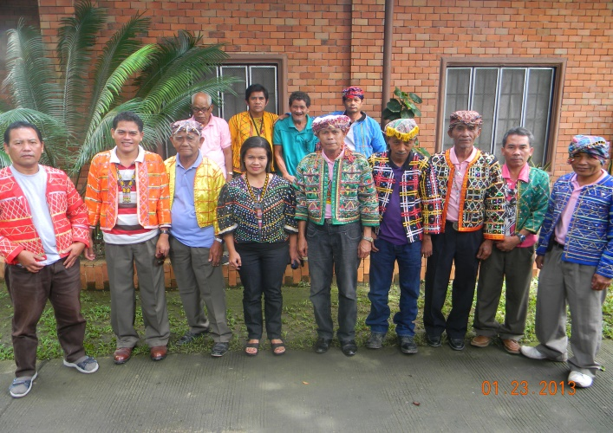 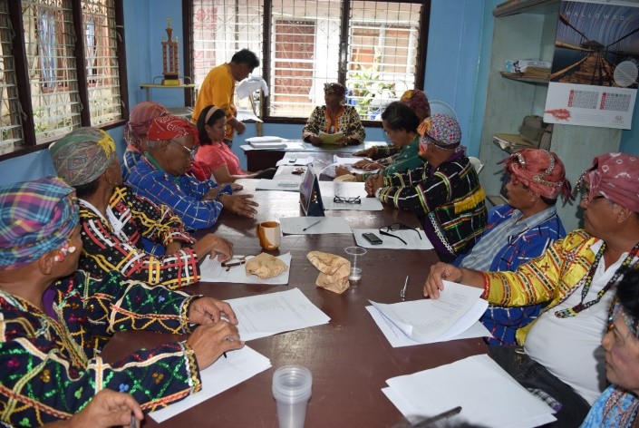

The members of the Cotabato Consultative Council for Development,Inc (CTCCDI) during the Board meetings

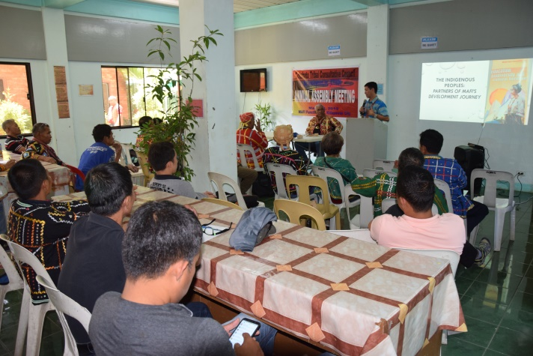 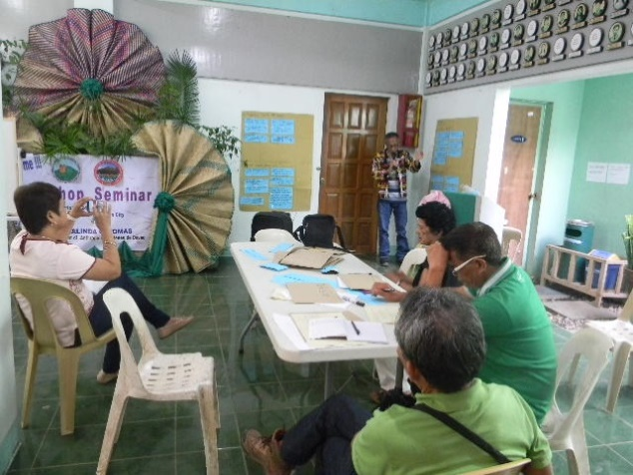

CTCCDI Participated during Cultural Heritage Seminar conducted by Dr. Rosalinda Tomas Atenio de Davao

Annual CTCCDI General Assembly meeting every March 7

**Indigenous Political Structures Formulation Project :**

One of the output during the 2 successive Cultural Heritage Program seminars was conducted by Dr. Rosalinda Tomas for the 3 sectors: tribal leaders, women’s sector and youth sector from Kidapawan City, and Municipalities of Makilala and Magpet. is to Formulate the Indigenous Political Structure ( IPS) of the Obu-Manobo around Mt Apo. This project is the part of the Cultural Heritage Program of the MAFI.

Base on the enactment of the Republic Act No. 8371 (RA.8371) otherwise known as the Indigenous People Rights Act (IPRA) of 1997 gave more weight to the indigenous people since their rights and well-being are now being recognized, protected and promoted. In the same aspect, the IPRA enumerated the following provision on the Rights to Ancestral domain

(Chapter III), Self Governance and Empowerment ( Chapter IV),Social Justice and Human Rights ( Chapter V), and Cultural Integrity (Chapter VI) in order to implement the promotion of the political economic and cultural

rights if the Indigenous Cultural Communities/Indigenous People(ICCs/IPs):

Chapter II, Section 3 (i) of RA 8371 defines Indigenous Political Structures (IPS) as referring to organizational and cultural leadership systems, institusions, relationship, patterns and processes for decision-making and participation identified and acceptable by ICCs/IPs (e.g.Council of Timuay, Bodong holders);

Therefore last July 8, 2019, the NCIP-North Cotabato facilitated the 1st Consultative Meeting for the formulation of the Indigenous Political Structure (IPS ) of Obu-Monuvu where the participants were the tribal leaders and CADC Holders coming from Kidapawan City, Municipality of Magpet and Lower President Roxas. This meeting was conducted with collaboration of NCIP,MAFI,EDC and CTCCDI. During the meeting the

tribal leaders signed a MOA to support the proposed formulation of the IPS of Obu-Manuvu.

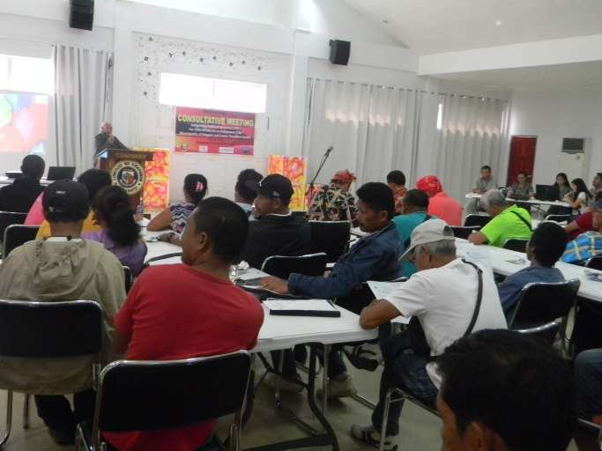 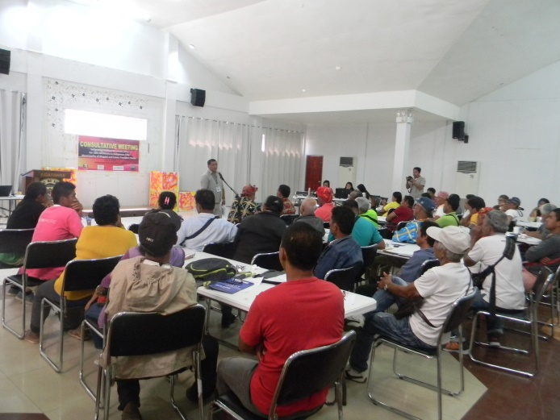

NCIP OIC Regional Director Datu Joey Bogay also attend the Consultative Meeting of the Indigenous Political Structure Formulation of Obo Manobo last February 2019

Datu Samuel Asicam Sr. MAFI Director, attend the Consultative Meeting of the Indigenous Political Structure Formulation of Obo Manobo last February 2019

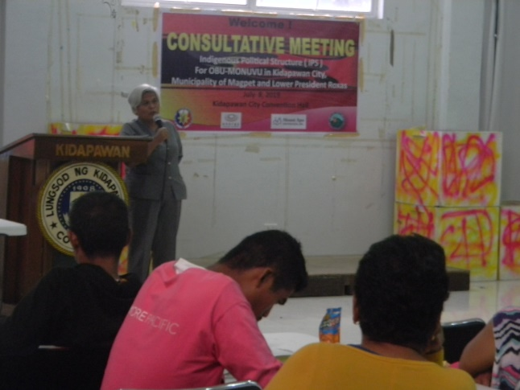 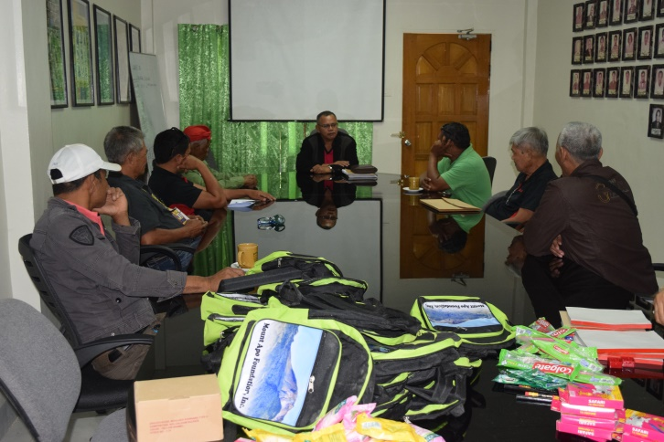

North Cotabato NCIP Provincial officer conduct meeting to the OBO Manobo tribal leaders at MAFI Boartd room November 23, 2018.regarding the proposed IPS of Obo Manobo

NCIP Commissioner Bai Era Espania also attend the Consultative Meeting of the Indigenous Political Structure Formulation of Obo Manobo last February 2019

**Kullivuungan to Apo Sondawa.**

Celebration of Kollivuungan to Apo Sondowa Festival successfully conducted at Sitio Sayabab, Ilomavis, Kidapawan City these event is yearly celebration of the IP every April 7, to showcase our dignity and pride of our rich cultural heritage, and to commemorate the birth anniversary of the late Datu Joseph G. Sibug, our beloved leader who championed the rights of the Indigenous People (IP).

The yearly activity was gladly supported by MAFI Board of Trustee upon the request of the tribal leaders by joint resolution of Barangay Tribal Leaders and MADADMA Council of Elders since 2017-2019.

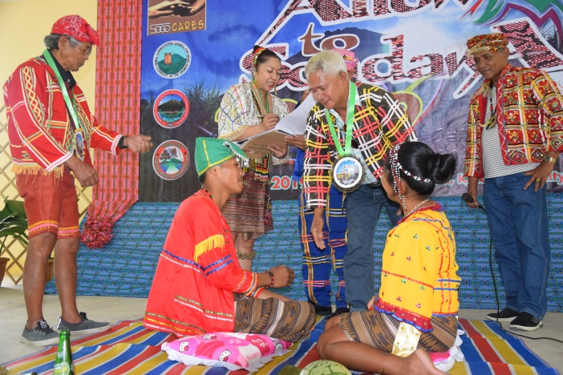 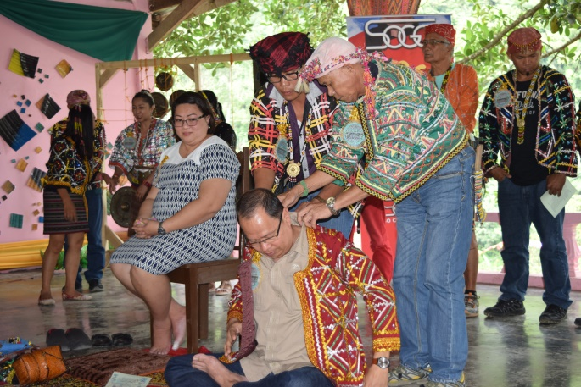

The Tribal weeding ceremony during the Allow to Sondawa 2019

The confirmation ceremony being a Datu’s and Boi’s of the Apo sondawa during the Allow to Sondawa 2018

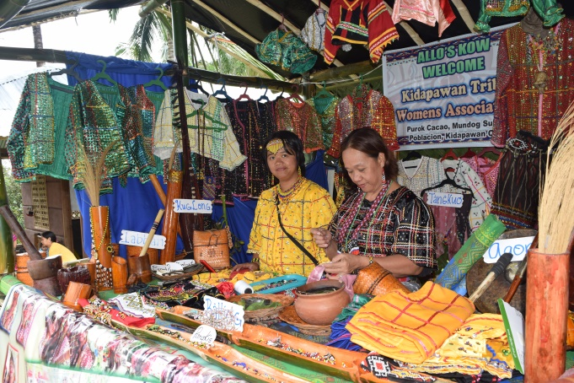 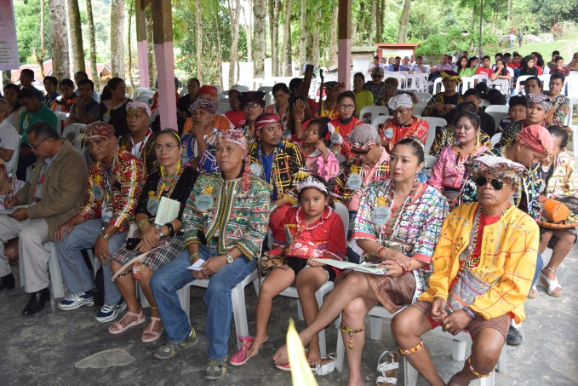

The Attendees of the Allow to Somdawa celebration from the Municipality of Magpet,Makilala and Kidapawan City

The Tribal Costume display during the Allow to Sondawa

